Current update about our working progress:

To detect and get license plate from the image of vehicle we have done the following work:

1) converting the image into BGR color format
2) Detecting the edges in the image
3) Identifying the license plate section by using ‘imutils’ python library, and crop the section on the image
4) And finally getting the license plate image

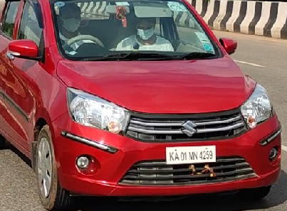
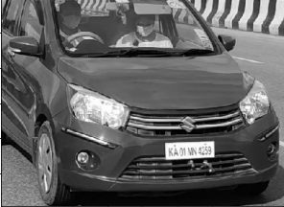
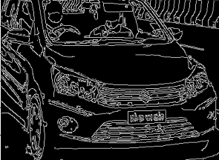
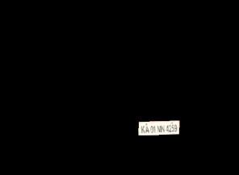
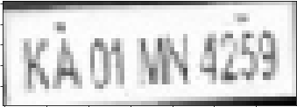
We are now working on getting letter from License plate image and calculating the speed of vehicle.
(1)
(2)
(3)
(4)

